Multiple VPC Networks

[favorite\_border](https://www.qwiklabs.com/favorite.json?item_id=1230&item_type=CatalogItem)

Add to favorites

help

90/100

Checkpoints

arrow\_forward

Create the managementnet network

Check my progress

20 / 20

Create the privatenet network

Check my progress

30 / 30

Create the firewall rules for managementnet

Check my progress

15 / 15

Create the firewall rules for privatenet

Check my progress

15 / 15

Create the managementnet-us-vm instance

Check my progress

5 / 5

Create the privatenet-us-vm instance

Check my progress

5 / 5

Create a VM instance with multiple network interfaces

Check my progress

0 / 10

End Lab

00:29:27

**Caution:** When you are in the console, do not deviate from the lab instructions. Doing so may cause your account to be blocked. [Learn more.](https://www.qwiklabs.com/focuses/1230?parent=catalog)

[Open Google Console](https://accounts.google.com/AddSession?service=accountsettings&continue=https%3A%2F%2Fconsole.cloud.google.com%2Fhome%2Fdashboard%3Fproject%3Dqwiklabs-gcp-00-d210da868802" \t "_blank)

Username



content\_copy

Password



content\_copy

GCP Project ID



content\_copy

[GSP211](https://www.qwiklabs.com/focuses/1230?parent=catalog#step1)[Overview](https://www.qwiklabs.com/focuses/1230?parent=catalog#step2)[Setup and Requirements](https://www.qwiklabs.com/focuses/1230?parent=catalog#step3)[Create custom mode VPC networks with firewall rules](https://www.qwiklabs.com/focuses/1230?parent=catalog#step4)[Create VM instances](https://www.qwiklabs.com/focuses/1230?parent=catalog#step5)[Explore the connectivity between VM instances](https://www.qwiklabs.com/focuses/1230?parent=catalog#step6)[Create a VM instance with multiple network interfaces](https://www.qwiklabs.com/focuses/1230?parent=catalog#step7)[Congratulations!](https://www.qwiklabs.com/focuses/1230?parent=catalog#step8)

Multiple VPC Networks

1 hour 10 minutes7 Credits

Rate Lab

**GSP211**



**Overview**

In this lab you create several VPC networks and VM instances and test connectivity across networks. Specifically, you create two custom mode networks (**managementnet** and **privatenet**) with firewall rules and VM instances as shown in this network diagram:

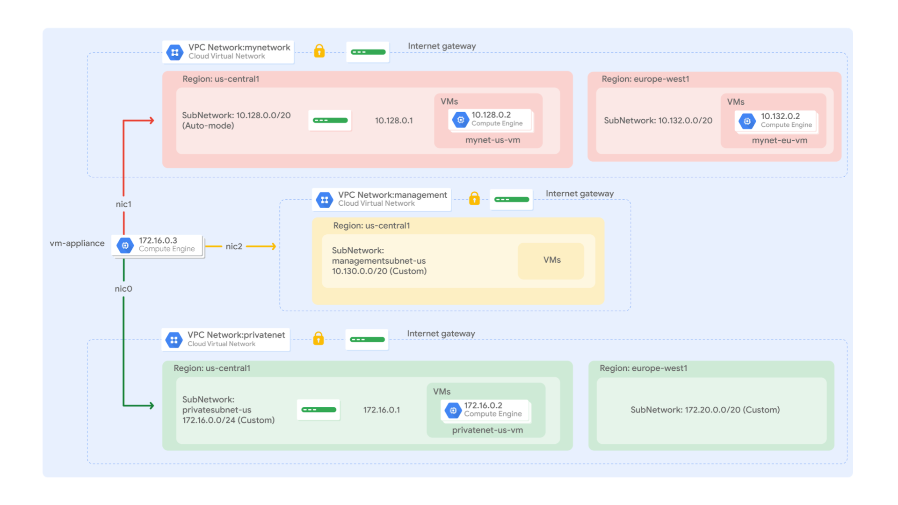

The **mynetwork** network with its firewall rules and two VM instances (**mynet-eu-vm** and **mynet-us-vm**) have already been created for you in this Qwiklabs project.

Objectives

In this lab, you will learn how to perform the following tasks:

* Create custom mode VPC networks with firewall rules
* Create VM instances using Compute Engine
* Explore the connectivity for VM instances across VPC networks
* Create a VM instance with multiple network interfaces

**Setup and Requirements**

**Before you click the Start Lab button**

Read these instructions. Labs are timed and you cannot pause them. The timer, which starts when you click **Start Lab**, shows how long Google Cloud resources will be made available to you.

This Qwiklabs hands-on lab lets you do the lab activities yourself in a real cloud environment, not in a simulation or demo environment. It does so by giving you new, temporary credentials that you use to sign in and access Google Cloud for the duration of the lab.

**What you need**

To complete this lab, you need:

* Access to a standard internet browser (Chrome browser recommended).
* Time to complete the lab.

**Note:** If you already have your own personal Google Cloud account or project, do not use it for this lab.

**Note:** If you are using a Pixelbook, open an Incognito window to run this lab.

**How to start your lab and sign in to the Google Cloud Console**

1. Click the **Start Lab** button. If you need to pay for the lab, a pop-up opens for you to select your payment method. On the left is a panel populated with the temporary credentials that you must use for this lab.

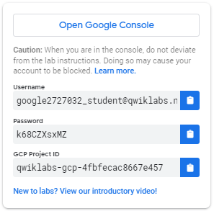

1. Copy the username, and then click **Open Google Console**. The lab spins up resources, and then opens another tab that shows the **Sign in** page.

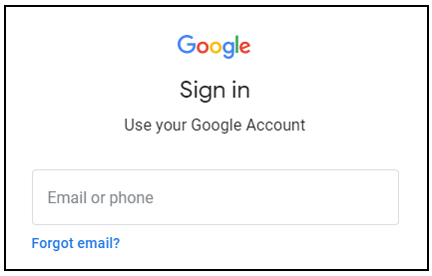

***Tip:*** Open the tabs in separate windows, side-by-side.

If you see the **Choose an account** page, click **Use Another Account**. 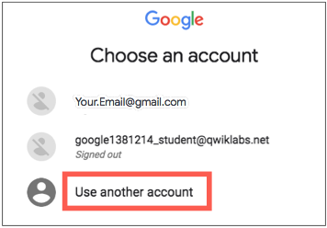

1. In the **Sign in** page, paste the username that you copied from the Connection Details panel. Then copy and paste the password.

***Important:*** You must use the credentials from the Connection Details panel. Do not use your Qwiklabs credentials. If you have your own Google Cloud account, do not use it for this lab (avoids incurring charges).

1. Click through the subsequent pages:
   * Accept the terms and conditions.
   * Do not add recovery options or two-factor authentication (because this is a temporary account).
   * Do not sign up for free trials.

After a few moments, the Cloud Console opens in this tab.

**Note:** You can view the menu with a list of Google Cloud Products and Services by clicking the **Navigation menu** at the top-left. 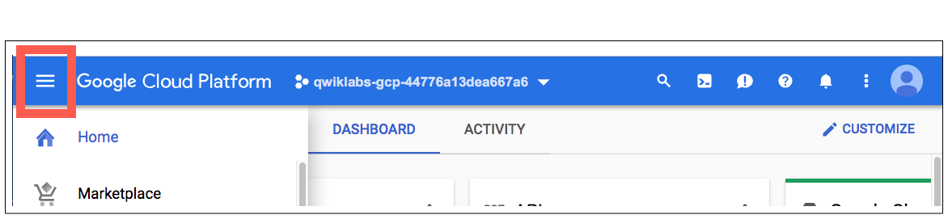

Activate Cloud Shell

Cloud Shell is a virtual machine that is loaded with development tools. It offers a persistent 5GB home directory and runs on the Google Cloud. Cloud Shell provides command-line access to your Google Cloud resources.

In the Cloud Console, in the top right toolbar, click the **Activate Cloud Shell** button.

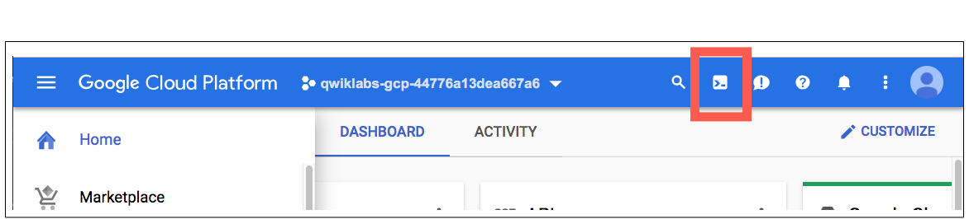

Click **Continue**.

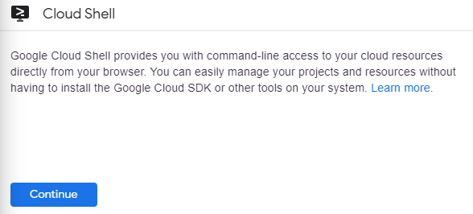

It takes a few moments to provision and connect to the environment. When you are connected, you are already authenticated, and the project is set to your *PROJECT\_ID*. For example:

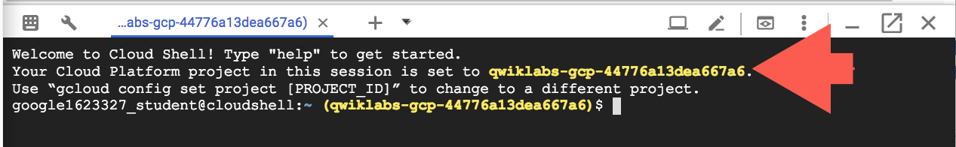

gcloud is the command-line tool for Google Cloud. It comes pre-installed on Cloud Shell and supports tab-completion.

You can list the active account name with this command:

gcloud auth list

(Output)

Credentialed accounts:

- <myaccount>@<mydomain>.com (active)

(Example output)

Credentialed accounts:

- google1623327\_student@qwiklabs.net

You can list the project ID with this command:

gcloud config list project

(Output)

[core]

project = <project\_ID>

(Example output)

[core]

project = qwiklabs-gcp-44776a13dea667a6

For full documentation of gcloud see the [gcloud command-line tool overview](https://cloud.google.com/sdk/gcloud" \t "_blank).

**Create custom mode VPC networks with firewall rules**

Create two custom networks **managementnet** and **privatenet**, along with firewall rules to allow **SSH**, **ICMP**, and **RDP** ingress traffic.

Create the managementnet network

Create the **managementnet** network using the Cloud Console.

1. In the Cloud Console, navigate to **Navigation menu** (mainmenu.png) > **VPC network** > **VPC networks**.

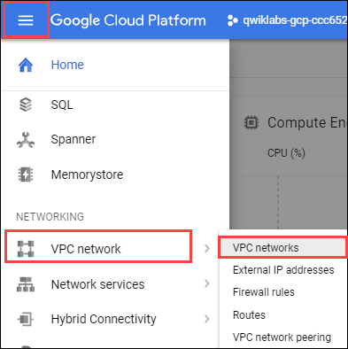

1. Notice the **default** and **mynetwork** networks with their subnets.

Each Google Cloud project starts with the **default** network. In addition, the **mynetwork** network has been premade as part of your network diagram.

1. Click **Create VPC Network**.
2. Set the **Name** to managementnet.
3. For **Subnet creation mode**, click **Custom**.
4. Set the following values, leave all other values at their defaults:

|  |  |
| --- | --- |
| **Property** | **Value (type value or select option as specified)** |
| Name | managementsubnet-us |
| Region | us-central1 |
| IP address range | 10.130.0.0/20 |

1. Click **Done**.
2. Click **command line**.

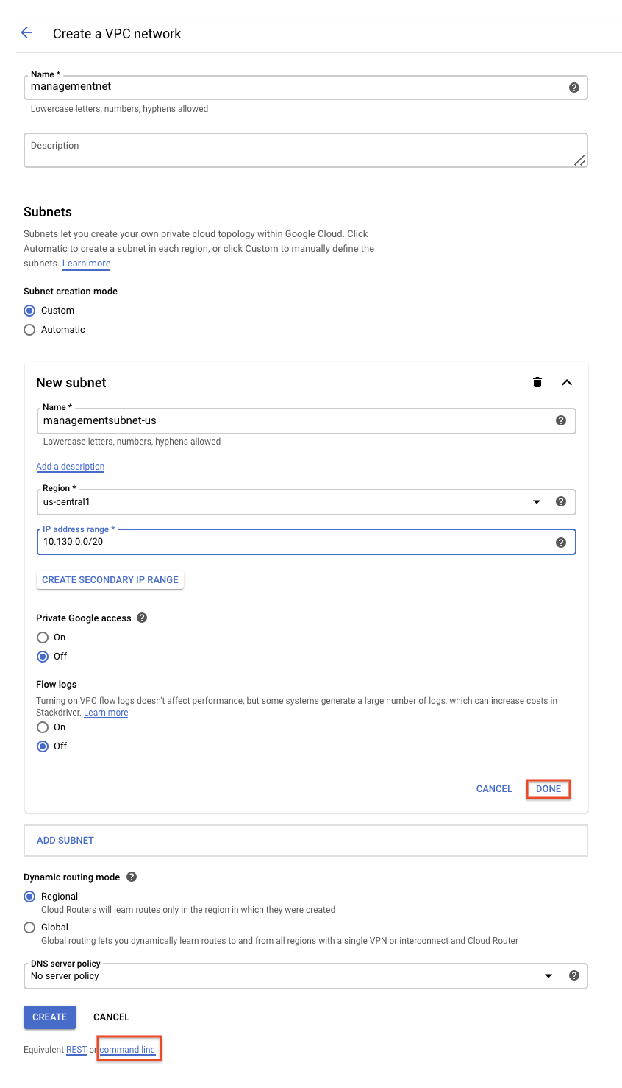

These commands illustrate that networks and subnets can be created using the Cloud Shell command line. You will create the **privatenet** network using these commands with similar parameters.

1. Click **Close**.
2. Click **Create**.

**Test Completed Task**

Click **Check my progress** to verify your performed task. If you have successfully created a managementnet network, you will see an assessment score.

Create the managementnet network

Check my progress

**Create the privatenet network**

Create the **privatenet** network using the Cloud Shell command line.

1. Run the following command to create the **privatenet** network:

gcloud compute networks create privatenet --subnet-mode=custom

1. Run the following command to create the **privatesubnet-us** subnet:

gcloud compute networks subnets create privatesubnet-us --network=privatenet --region=us-central1 --range=172.16.0.0/24

1. Run the following command to create the **privatesubnet-eu** subnet:

gcloud compute networks subnets create privatesubnet-eu --network=privatenet --region=europe-west1 --range=172.20.0.0/20

**Test Completed Task**

Click **Check my progress** to verify your performed task. If you have successfully created a privatenet network, you will see an assessment score.

Create the privatenet network

Check my progress

1. Run the following command to list the available VPC networks:

gcloud compute networks list

The output should look like this (**do not copy; this is example output**):

NAME SUBNET\_MODE BGP\_ROUTING\_MODE IPV4\_RANGE GATEWAY\_IPV4

default AUTO REGIONAL

managementnet CUSTOM REGIONAL

mynetwork AUTO REGIONAL

privatenet CUSTOM REGIONAL

**default** and **mynetwork** are auto mode networks, whereas, **managementnet** and **privatenet** are custom mode networks. Auto mode networks create subnets in each region automatically, while custom mode networks start with no subnets, giving you full control over subnet creation

1. Run the following command to list the available VPC subnets (sorted by VPC network):

gcloud compute networks subnets list --sort-by=NETWORK

The output should look like this (**do not copy; this is example output**):

NAME REGION NETWORK RANGE

default asia-northeast1 default 10.146.0.0/20

default us-west1 default 10.138.0.0/20

default southamerica-east1 default 10.158.0.0/20

default europe-west4 default 10.164.0.0/20

default asia-east1 default 10.140.0.0/20

default europe-north1 default 10.166.0.0/20

default asia-southeast1 default 10.148.0.0/20

default us-east4 default 10.150.0.0/20

default europe-west1 default 10.132.0.0/20

default europe-west2 default 10.154.0.0/20

default europe-west3 default 10.156.0.0/20

default australia-southeast1 default 10.152.0.0/20

default asia-south1 default 10.160.0.0/20

default us-east1 default 10.142.0.0/20

default us-central1 default 10.128.0.0/20

default northamerica-northeast1 default 10.162.0.0/20

managementsubnet-us us-central1 managementnet 10.130.0.0/20

mynetwork asia-northeast1 mynetwork 10.146.0.0/20

mynetwork us-west1 mynetwork 10.138.0.0/20

mynetwork southamerica-east1 mynetwork 10.158.0.0/20

mynetwork europe-west4 mynetwork 10.164.0.0/20

mynetwork asia-east1 mynetwork 10.140.0.0/20

mynetwork europe-north1 mynetwork 10.166.0.0/20

mynetwork asia-southeast1 mynetwork 10.148.0.0/20

mynetwork us-east4 mynetwork 10.150.0.0/20

mynetwork europe-west1 mynetwork 10.132.0.0/20

mynetwork europe-west2 mynetwork 10.154.0.0/20

mynetwork europe-west3 mynetwork 10.156.0.0/20

mynetwork australia-southeast1 mynetwork 10.152.0.0/20

mynetwork asia-south1 mynetwork 10.160.0.0/20

mynetwork us-east1 mynetwork 10.142.0.0/20

mynetwork us-central1 mynetwork 10.128.0.0/20

mynetwork northamerica-northeast1 mynetwork 10.162.0.0/20

privatesubnet-eu europe-west1 privatenet 172.20.0.0/20

privatesubnet-us us-central1 privatenet 172.16.0.0/24

As expected, the **default** and **mynetwork** networks have subnets in [each region](https://cloud.google.com/compute/docs/regions-zones/#available) as they are auto mode networks. The **managementnet** and **privatenet** networks only have the subnets that you created as they are custom mode networks.

1. In the Cloud Console, navigate to **Navigation menu** > **VPC network** > **VPC networks**.
2. You see that the same networks and subnets are listed in the Cloud Console.

Create the firewall rules for managementnet

Create firewall rules to allow **SSH**, **ICMP**, and **RDP** ingress traffic to VM instances on the **managementnet** network.

1. In the Cloud Console, navigate to **Navigation menu** (mainmenu.png) > **VPC network** > **Firewall**.
2. Click **+ Create Firewall Rule**.
3. Set the following values, leave all other values at their defaults:

|  |  |
| --- | --- |
| **Property** | **Value (type value or select option as specified)** |
| Name | managementnet-allow-icmp-ssh-rdp |
| Network | managementnet |
| Targets | All instances in the network |
| Source filter | IP Ranges |
| Source IP ranges | 0.0.0.0/0 |
| Protocols and ports | Specified protocols and ports, and then *check* tcp, *type:* 22, 3389; and *check* Other protocols, *type:* icmp. |

Make sure to include the **/0** in the **Source IP ranges** to specify all networks.

1. Click **command line**.

These commands illustrate that firewall rules can also be created using the Cloud Shell command line. You will create the **privatenet**'s firewall rules using these commands with similar parameters.

1. Click **Close**.
2. Click **Create**.

**Test Completed Task**

Click **Check my progress** to verify your performed task. If you have successfully created firewall rules for managementnet network, you will see an assessment score.

Create the firewall rules for managementnet

Check my progress

Create the firewall rules for privatenet

Create the firewall rules for **privatenet** network using the Cloud Shell command line.

1. In Cloud Shell, run the following command to create the **privatenet-allow-icmp-ssh-rdp** firewall rule:

gcloud compute firewall-rules create privatenet-allow-icmp-ssh-rdp --direction=INGRESS --priority=1000 --network=privatenet --action=ALLOW --rules=icmp,tcp:22,tcp:3389 --source-ranges=0.0.0.0/0

The output should look like this (**do not copy; this is example output**):

NAME NETWORK DIRECTION PRIORITY ALLOW DENY

privatenet-allow-icmp-ssh-rdp privatenet INGRESS 1000 icmp,tcp:22,tcp:3389

**Test Completed Task**

Click **Check my progress** to verify your performed task. If you have successfully created firewall rules for privatenet network, you will see an assessment score.

Create the firewall rules for privatenet

Check my progress

1. Run the following command to list all the firewall rules (sorted by VPC network):

gcloud compute firewall-rules list --sort-by=NETWORK

The output should look like this (**do not copy; this is example output**):

NAME NETWORK DIRECTION PRIORITY ALLOW DENY

default-allow-icmp default INGRESS 65534 icmp

default-allow-internal default INGRESS 65534 tcp:0-65535,udp:0-65535,icmp

default-allow-rdp default INGRESS 65534 tcp:3389

default-allow-ssh default INGRESS 65534 tcp:22

managementnet-allow-icmp-ssh-rdp managementnet INGRESS 1000 icmp,tcp:22,tcp:3389

mynetwork-allow-icmp mynetwork INGRESS 1000 icmp

mynetwork-allow-rdp mynetwork INGRESS 1000 tcp:3389

mynetwork-allow-ssh mynetwork INGRESS 1000 tcp:22

privatenet-allow-icmp-ssh-rdp privatenet INGRESS 1000 icmp,tcp:22,tcp:3389

The firewall rules for **mynetwork** network have been created for you. You can define multiple protocols and ports in one firewall rule (**privatenet** and **managementnet**), or spread them across multiple rules (**default** and **mynetwork**).

1. In the Cloud Console, navigate to **Navigation menu** > **VPC network** > **Firewall**.
2. You see that the same firewall rules are listed in the Cloud Console.

**Create VM instances**

Create two VM instances:

* **managementnet-us-vm** in **managementsubnet-us**
* **privatenet-us-vm** in **privatesubnet-us**

Create the managementnet-us-vm instance

Create the **managementnet-us-vm** instance using the Cloud Console.

1. In the Cloud Console, navigate to **Navigation menu** > **Compute Engine** > **VM instances**.

The **mynet-eu-vm** and **mynet-us-vm** has been created for you, as part of your network diagram.

1. Click **Create instance**.
2. Set the following values, leave all other values at their defaults:

|  |  |
| --- | --- |
| **Property** | **Value (type value or select option as specified)** |
| Name | managementnet-us-vm |
| Region | us-central1 |
| Zone | us-central1-c |
| Series | N1 |
| Machine type | 1 vCPU (f1-micro) |

1. Click **Management, security, disks, networking, sole tenancy**.
2. Click **Networking**.
3. For **Network interfaces**, click the pencil icon to edit.
4. Set the following values, leave all other values at their defaults:

|  |  |
| --- | --- |
| **Property** | **Value (type value or select option as specified)** |
| Network | managementnet |
| Subnetwork | managementsubnet-us |

1. Click **Done**.
2. Click **command line**.

This illustrate that VM instances can also be created using the Cloud Shell command line. You will create the **privatenet-us-vm** instance using these commands with similar parameters.

1. Click **Close**.
2. Click **Create**.

**Test Completed Task**

Click **Check my progress** to verify your performed task. If you have successfully created VM instance in managementnet network, you will see an assessment score.

Create the managementnet-us-vm instance

Check my progress

Create the privatenet-us-vm instance

Create the **privatenet-us-vm** instance using the Cloud Shell command line.

1. In Cloud Shell, run the following command to create the **privatenet-us-vm** instance:

gcloud compute instances create privatenet-us-vm --zone=us-central1-c --machine-type=n1-standard-1 --subnet=privatesubnet-us

The output should look like this (**do not copy; this is example output**):

NAME ZONE MACHINE\_TYPE PREEMPTIBLE INTERNAL\_IP EXTERNAL\_IP STATUS

privatenet-us-vm us-central1-c n1-standard-1 172.16.0.2 35.184.221.40 RUNNING

**Test Completed Task**

Click **Check my progress** to verify your performed task. If you have successfully created VM instance in privatenet network, you will see an assessment score.

Create the privatenet-us-vm instance

Check my progress

1. Run the following command to list all the VM instances (sorted by zone):

gcloud compute instances list --sort-by=ZONE

The output should look like this (**do not copy; this is example output**):

NAME ZONE MACHINE\_TYPE PREEMPTIBLE INTERNAL\_IP EXTERNAL\_IP STATUS

mynet-eu-vm europe-west1-c n1-standard-1 10.132.0.2 35.205.124.164 RUNNING

managementnet-us-vm us-central1-c n1-standard-1 10.130.0.2 35.226.20.87 RUNNING

mynet-us-vm us-central1-c n1-standard-1 10.128.0.2 35.232.252.86 RUNNING

privatenet-us-vm us-central1-c n1-standard-1 172.16.0.2 35.184.221.40 RUNNING

1. In the Cloud Console, navigate to **Navigation menu** (mainmenu.png) > **Compute Engine** > **VM instances**.
2. You see that the VM instances are listed in the Cloud Console.
3. Click on **Columns**, then select **Network**.

There are three instances in **us-central1-c** and one instance in **europe-west1-c**. However, these instances are spread across three VPC networks (**managementnet**, **mynetwork** and **privatenet**), with no instance in the same zone and network as another. In the next section, you explore the effect this has on internal connectivity.

**Explore the connectivity between VM instances**

Explore the connectivity between the VM instances. Specifically, determine the effect of having VM instances in the same zone versus having instances in the same VPC network.

Ping the external IP addresses

Ping the external IP addresses of the VM instances to determine if you can reach the instances from the public internet.

1. In the Cloud Console, navigate to **Navigation menu** > **Compute Engine** > **VM instances**.
2. Note the external IP addressees for **mynet-eu-vm**, **managementnet-us-vm**, and **privatenet-us-vm**.
3. For **mynet-us-vm**, click **SSH** to launch a terminal and connect.
4. To test connectivity to **mynet-eu-vm**'s external IP, run the following command, replacing **mynet-eu-vm**'s external IP:

ping -c 3 <Enter mynet-eu-vm's external IP here>

This should work!

1. To test connectivity to **managementnet-us-vm**'s external IP, run the following command, replacing **managementnet-us-vm**'s external IP:

ping -c 3 <Enter managementnet-us-vm's external IP here>

This should work!

1. To test connectivity to **privatenet-us-vm**'s external IP, run the following command, replacing **privatenet-us-vm**'s external IP:

ping -c 3 <Enter privatenet-us-vm's external IP here>

This should work!

You are able to ping the external IP address of all VM instances, even though they are either in a different zone or VPC network. This confirms public access to those instances is only controlled by the **ICMP** firewall rules that you established earlier.

Ping the internal IP addresses

Ping the internal IP addresses of the VM instances to determine if you can reach the instances from within a VPC network.

1. In the Cloud Console, navigate to **Navigation menu** > **Compute Engine** > **VM instances**.
2. Note the internal IP addressees for **mynet-eu-vm**, **managementnet-us-vm**, and **privatenet-us-vm**.
3. Return to the **SSH** terminal for **mynet-us-vm**.
4. To test connectivity to **mynet-eu-vm**'s internal IP, run the following command, replacing **mynet-eu-vm**'s internal IP:

ping -c 3 <Enter mynet-eu-vm's internal IP here>

You are able to ping the internal IP address of **mynet-eu-vm** because it is on the same VPC network as the source of the ping (**mynet-us-vm**), even though both VM instances are in separate zones, regions and continents!

1. To test connectivity to **managementnet-us-vm**'s internal IP, run the following command, replacing **managementnet-us-vm**'s internal IP:

ping -c 3 <Enter managementnet-us-vm's internal IP here>

This should not work as indicated by a 100% packet loss!

1. To test connectivity to **privatenet-us-vm**'s internal IP, run the following command, replacing **privatenet-us-vm**'s internal IP:

ping -c 3 <Enter privatenet-us-vm's internal IP here>

This should not work either as indicated by a 100% packet loss! You are unable to ping the internal IP address of **managementnet-us-vm** and **privatenet-us-vm** because they are in separate VPC networks from the source of the ping (**mynet-us-vm**), even though they are all in the same zone **us-central1**.

VPC networks are by default isolated private networking domains. However, no internal IP address communication is allowed between networks, unless you set up mechanisms such as VPC peering or VPN.

Which instance(s) should you be able to ping from mynet-us-vm using internal IP addresses?



privatenet-us-vm

checkmynet-eu-vm



managementnet-us-vm

Submit

**Create a VM instance with multiple network interfaces**

Every instance in a VPC network has a default network interface. You can create additional network interfaces attached to your VMs. Multiple network interfaces enable you to create configurations in which an instance connects directly to several VPC networks (up to 8 interfaces, depending on the instance's type).

Create the VM instance with multiple network interfaces

Create the **vm-appliance** instance with network interfaces in **privatesubnet-us**, **managementsubnet-us** and **mynetwork**. The CIDR ranges of these subnets do not overlap, which is a requirement for creating a VM with multiple network interface controllers (NICs).

1. In the Cloud Console, navigate to **Navigation menu** > **Compute Engine** > **VM instances**.
2. Click **Create instance**.
3. Set the following values, leave all other values at their defaults:

|  |  |
| --- | --- |
| **Property** | **Value (type value or select option as specified)** |
| Name | vm-appliance |
| Region | us-central1 |
| Zone | us-central1-c |
| Series | N1 |
| Machine type | 4 vCPUs (n1-standard-4) |

The number of interfaces allowed in an instance is dependent on the instance's machine type and the number of vCPUs. The n1-standard-4 allows up to 4 network interfaces. Refer [here](https://cloud.google.com/vpc/docs/create-use-multiple-interfaces#max-interfaces) for more information.

1. Click **Management, security, disks, networking, sole tenancy**.
2. Click **Networking**.
3. For **Network interfaces**, click the pencil icon to edit.
4. Set the following values, leave all other values at their defaults:

|  |  |
| --- | --- |
| **Property** | **Value (type value or select option as specified)** |
| Network | privatenet |
| Subnetwork | privatesubnet-us |

1. Click **Done**.
2. Click **Add network interface**.
3. Set the following values, leave all other values at their defaults:

|  |  |
| --- | --- |
| **Property** | **Value (type value or select option as specified)** |
| Network | managementnet |
| Subnetwork | managementsubnet-us |

1. Click **Done**.
2. Click **Add network interface**.
3. Set the following values, leave all other values at their defaults:

|  |  |
| --- | --- |
| **Property** | **Value (type value or select option as specified)** |
| Network | mynetwork |
| Subnetwork | mynetwork |

1. Click **Done**.
2. Click **Create**.

**Test Completed Task**

Click **Check my progress** to verify your performed task. If you have successfully created VM instance with multiple network interfaces, you will see an assessment score.

Create a VM instance with multiple network interfaces

Check my progress

Explore the network interface details

Explore the network interface details of **vm-appliance** within the Cloud Console and within the VM's terminal.

1. In the Cloud Console, navigate to **Navigation menu** (mainmenu.png) > **Compute Engine** > **VM instances**.
2. Click **nic0** within the **Internal IP** address of **vm-appliance** to open the **Network interface details** page.
3. Verify that **nic0** is attached to **privatesubnet-us**, is assigned an internal IP address within that subnet (172.16.0.0/24), and has applicable firewall rules.
4. Click **nic0** and select **nic1**.
5. Verify that **nic1** is attached to **managementsubnet-us**, is assigned an internal IP address within that subnet (10.130.0.0/20), and has applicable firewall rules.
6. Click **nic1** and select **nic2**.
7. Verify that **nic2** is attached to **mynetwork**, is assigned an internal IP address within that subnet (10.128.0.0/20), and has applicable firewall rules.

Each network interface has its own internal IP address so that the VM instance can communicate with those networks.

1. In the Cloud Console, navigate to **Navigation menu** > **Compute Engine** > **VM instances**.
2. For **vm-appliance**, click **SSH** to launch a terminal and connect.
3. Run the following, to list the network interfaces within the VM instance:

sudo ifconfig

The output should look like this (**do not copy; this is example output**):

eth0: flags=4163<UP,BROADCAST,RUNNING,MULTICAST> mtu 1460

inet 172.16.0.3 netmask 255.255.255.255 broadcast 172.16.0.3

inet6 fe80::4001:acff:fe10:3 prefixlen 64 scopeid 0x20<link>

ether 42:01:ac:10:00:03 txqueuelen 1000 (Ethernet)

RX packets 626 bytes 171556 (167.5 KiB)

RX errors 0 dropped 0 overruns 0 frame 0

TX packets 568 bytes 62294 (60.8 KiB)

TX errors 0 dropped 0 overruns 0 carrier 0 collisions 0

eth1: flags=4163<UP,BROADCAST,RUNNING,MULTICAST> mtu 1460

inet 10.130.0.3 netmask 255.255.255.255 broadcast 10.130.0.3

inet6 fe80::4001:aff:fe82:3 prefixlen 64 scopeid 0x20<link>

ether 42:01:0a:82:00:03 txqueuelen 1000 (Ethernet)

RX packets 7 bytes 1222 (1.1 KiB)

RX errors 0 dropped 0 overruns 0 frame 0

TX packets 17 bytes 1842 (1.7 KiB)

TX errors 0 dropped 0 overruns 0 carrier 0 collisions 0

eth2: flags=4163<UP,BROADCAST,RUNNING,MULTICAST> mtu 1460

inet 10.128.0.3 netmask 255.255.255.255 broadcast 10.128.0.3

inet6 fe80::4001:aff:fe80:3 prefixlen 64 scopeid 0x20<link>

ether 42:01:0a:80:00:03 txqueuelen 1000 (Ethernet)

RX packets 17 bytes 2014 (1.9 KiB)

RX errors 0 dropped 0 overruns 0 frame 0

TX packets 17 bytes 1862 (1.8 KiB)

TX errors 0 dropped 0 overruns 0 carrier 0 collisions 0

The **sudo ifconfig** command lists a Linux VM's network interfaces along with the internal IP addresses for each interface.

Explore the network interface connectivity

Demonstrate that the **vm-appliance** instance is connected to **privatesubnet-us**, **managementsubnet-us** and **mynetwork** by pinging VM instances on those subnets.

1. In the Cloud Console, navigate to **Navigation menu** > **Compute Engine** > **VM instances**.
2. Note the internal IP addressees for **privatenet-us-vm**, **managementnet-us-vm**, **mynet-us-vm**, and **mynet-eu-vm**.
3. Return to the **SSH** terminal for **vm-appliance**.
4. To test connectivity to **privatenet-us-vm**'s internal IP, run the following command, replacing **privatenet-us-vm**'s internal IP:

ping -c 3 <Enter privatenet-us-vm's internal IP here>

This works!

1. Repeat the same test by running the following:

ping -c 3 privatenet-us-vm

You are able to ping **privatenet-us-vm** by its name because VPC networks have an internal DNS service that allows you to address instances by their DNS names rather than their internal IP addresses. When an internal DNS query is made with the instance hostname, it resolves to the primary interface (nic0) of the instance. Therefore, this only works for **privatenet-us-vm** in this case.

1. To test connectivity to **managementnet-us-vm**'s internal IP, run the following command, replacing **managementnet-us-vm**'s internal IP:

ping -c 3 <Enter managementnet-us-vm's internal IP here>

This works!

1. To test connectivity to **mynet-us-vm**'s internal IP, run the following command, replacing **mynet-us-vm**'s internal IP:

ping -c 3 <Enter mynet-us-vm's internal IP here>

This works!

1. To test connectivity to **mynet-eu-vm**'s internal IP, run the following command, replacing **mynet-eu-vm**'s internal IP:

ping -c 3 <Enter mynet-eu-vm's internal IP here>

This does not work! In a multiple interface instance, every interface gets a route for the subnet that it is in. In addition, the instance gets a single default route that is associated with the primary interface eth0. Unless manually configured otherwise, any traffic leaving an instance for any destination other than a directly connected subnet will leave the instance via the default route on eth0.

1. To list the routes for **vm-appliance** instance, run the following command:

ip route

The output should look like this (**do not copy; this is example output**):

default via 172.16.0.1 dev eth0

10.128.0.0/20 via 10.128.0.1 dev eth2

10.128.0.1 dev eth2 scope link

10.130.0.0/20 via 10.130.0.1 dev eth1

10.130.0.1 dev eth1 scope link

172.16.0.0/24 via 172.16.0.1 dev eth0

172.16.0.1 dev eth0 scope link

The primary interface eth0 gets the default route (default via 172.16.0.1 dev eth0), and all three interfaces eth0, eth1 and eth2 get routes for their respective subnets. Since, the subnet of **mynet-eu-vm** (**10.132.0.0/20**) is not included in this routing table, the ping to that instance leaves **vm-appliance** on eth0 (which is on a different VPC network). You could change this behavior by configuring policy routing as documented [here](https://cloud.google.com/vpc/docs/create-use-multiple-interfaces#configuring_policy_routing).

**Congratulations!**

In this lab you created several custom mode VPC networks, firewall rules and VM instances using the Cloud Console and the Cloud Shell command line. Then, you tested the connectivity across VPC networks which worked when pinging external IP addresses but not when pinging internal IP addresses. Thus, you created a VM instance with three network interfaces and verified internal connectivity for VM instances that are on the subnets that are attached to the multiple interface VM.

You also explored the default network along with its subnets, routes, and firewall rules. You deleted the default network and determined that you cannot create any VM instances without a VPC network. Thus, you created a new auto mode VPC network with subnets, routes, firewall rules and two VM instances. Then, you tested the connectivity for the VM instances and explored the effects of the firewall rules on connectivity.